**Mountains:**

Mount Godwin-Austen/K2

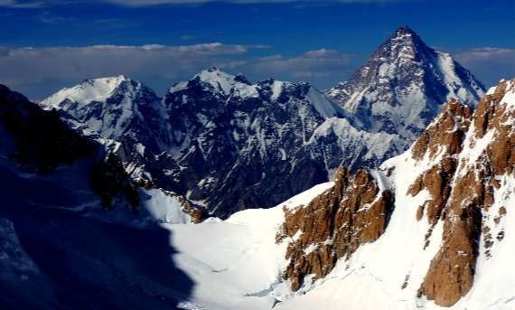

**K2** ( **Kai Ṭū**), also known as **Mount Godwin-Austen** or **Chhogori** at 8,611 metres (28,251ft) above sea level, is the second highest mountain in the world, after Mount Everest at 8,848 metres (29,029ft). It is located on the China–Pakistan border between Baltistan in the Gilgit-Baltistan region of northern Pakistan, and the Taxkorgan Tajik Autonomous County of Xinjiang, China. K2 is the highest point of the Karakoram range and the highest point in both Pakistan and Xinjiang. K2 is known as the *Savage Mountain* due to the extreme difficulty of ascent. It has the second-highest fatality rate among the eight-thousanders, with around 300 successful summits and 77 fatalities; about one person dies on the mountain for every four who reach the summit. It is more difficult and hazardous to reach the peak of K2 from the Chinese side, so it is usually climbed from the Pakistani side.  K2 has never been climbed during winter, unlike Annapurna, the mountain with the highest fatality-to-summit rate (191 summits and 61 fatalities), or the other eight-thousanders. Ascents have almost always been made in July and August, the warmest times of year; K2's more northern location makes it more susceptible to inclement and colder weather.